**KWAME NKRUMAH UNIVERSITY OF SCIENCE AND TECHNOLOGY, KUMASI**

**COLLEGE OF ENGINEERING**

B.Sc. (Engineering) Mid-Semester Examination March, 2020

Third Year

AERO 374 Air Vehicle Performance

**Time: 1 hour**

Q1.

The gross weight of a piper PA-28-181 is 2450 lb. It takes off from the runway at an airport with the conditions given on the PA-28-181 takeoff performance chart provided. If the altimeter reading at takeoff is 3500 ft and the altimeter setting is 28.8 inches Hg:

1. Find the pressure altitude at the airport.
2. Find the density altitude at the airport if the prevailing temperature at the airport is 10 ºC.
3. Find the ground roll at takeoff, if and the wind at the airport is a 10 knots headwind.

**10 marks**

Q2.

An aircraft was loaded with the load distribution given in Table 1,

**10 marks**

1. Calculate the respective moments of the listed items on the aircraft and use it to fill the table.

Table 1: Load Distribution in an Aircraft

|  |  |  |  |
| --- | --- | --- | --- |
| **Item** | **Weight (lb)** | **Arm (in)** | **Moment (lb-in)** |
| Basic Empty Weight | 1200 | 41 |  |
| Pilot and Front Passenger | 420 | 35 |  |
| Passenger Rear seat | 350 | 74 |  |
| Baggage | 50 | 100 |  |
| Fuel | 180 | 50 |  |
| Oil | 10 | -11 |  |
| **Total** |  | XXXXX |  |

1. Find the centre of gravity of the loaded aircraft at takeoff.
2. Indicate the centre of gravity calculated in (b) on the safety envelope provided.

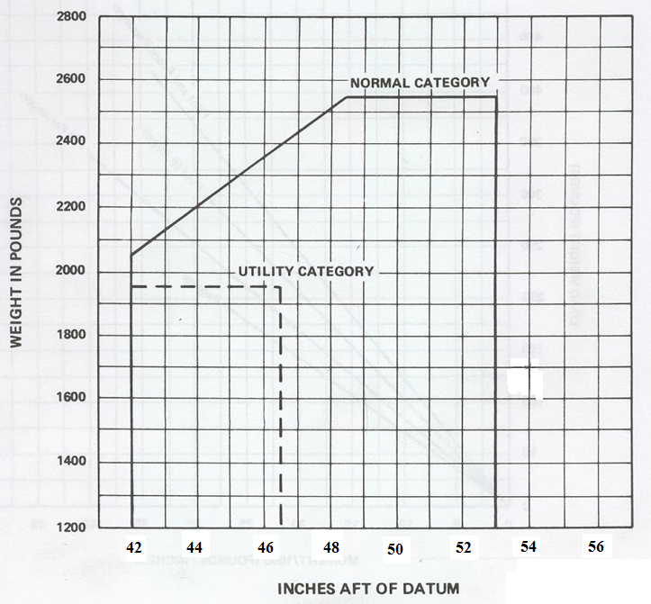

1. From your results in (c) comment on the flight readiness of the aircraft, whether it is safe for take-off and give reasons.

A. Agyei-Agyemang

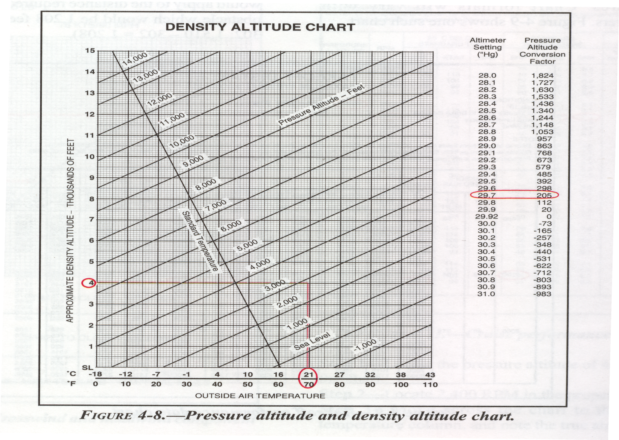

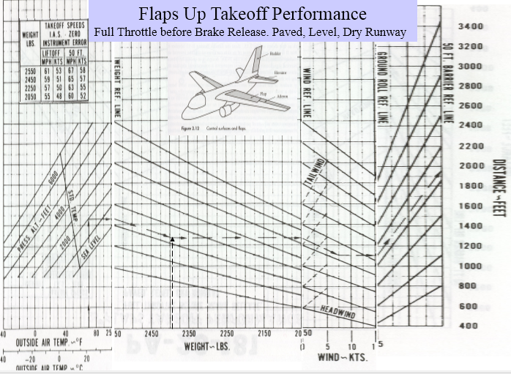

**Formula Sheet**

 hp = 550 ft lb/sec

$T=\left({\dot{m}}_{air}+{\dot{m}}_{fuel}\right)V_{j}-{\dot{m}}_{air}V_{∞}+\left(P_{e}-P_{∞}\right)A_{e}$

$T=\dot{m}(V_{j}-V_{∞})$; $\dot{m}=ρVA$ 5280 *ft* = 1 *mile*;

Service Altitude = *h*(*R/C max* = 100 ft/min.)

; 

g = 9.21 *m/s2* = 32.2 *ft/s2*

1 *hp* = 550 *ft lb/sec;* 

;  ; ; g = 9.21 *m/s2* = 32.2 *ft/s2*

; ; ; ;

A. Agyei-Agyemang